Mental Health Services Home Pack
In these unprecedented times, Mental Health Services within the Derry area are following the advice of the World Health Organisation (WHO) to try to prevent the spread of the virus and protect both clients and staff.

In the meantime, we appreciate that this can be a very worrying and difficult time for our clients, and so have put together this home pack with suggestions of how we can all keep safe and well in these uncertain times. These have been adapted from advice published by various bodies, including the Royal College of Occupational Therapy and The Mental Health Foundation.
Self-isolation, social distancing and the restrictions placed on all of us during this time do not mean that we can no longer engage in the things that we enjoy and give us purpose; instead we are challenged to find ways of adapting these to fit the restrictions but also provide us with a sense of meaning and enjoyment. Here are 5 ways of keeping ourselves well throughout the next number of weeks and months. Throughout this pack, we have provided simple examples of ways to achieve these, but feel free to add your own!

1.Establish a balanced daily routine of work, rest and leisure activities
It can be difficult to achieve things we need and want to get done in a day without some idea of a routine. Some people find it useful to plan and write down a plan for the day to follow to ensure everything is ticked off. It can be satisfying at the end of the day to tick off all that you have achieved. Regular routines are also essential for our identity, self-confidence and purpose. It is important to include ample periods of rest in our routines alongside work (necessary) tasks, e.g. housework, meal preparation, and leisure activities that we enjoy. We have provided an example of a simple timetable in Appendix 1 which you can print off.

2. Take care of yourself. Eat and drink healthily with plenty of fruit, vegetables and water to support your immune function and energy levels
During this time where we are spending more and more time in our homes, it can be difficult to maintain a healthy balanced eating routine. It is important to ensure you eat 3 balanced meals per day and keep hydrated, drinking plenty of water. It is a good idea to use the time to try out new recipes, try new foods and make those recipes you’ve left behind over the years. We have included some simple recipes to kick start your interest in Appendix 2.

3. Avoid staying still for too long. Exercise and regular movement will maintain fitness and strength. If you are working from home, take breaks and eat away from your “desk”
It is important to do some type of exercise daily, whether that be a walk, run, cycle, gym class or yoga. Exercise causes the body to produce natural ‘feel-good hormones’ and improves our mental and physical health. The recommended exercise daily is 30mins, but this can be broken up throughout the day. With current restrictions on our movement outside our own homes, we are advised to have one form of exercise per day outside our own homes. This is a good opportunity for a walk, run or cycle. If you prefer to exercise from your own home, there are lots of exercises that you can do both using internet and using paper instructions. We have provided some useful resources for both online exercise classes, and some paper instructions for those without internet access in Appendix 3. Why not give it a go!

4. Have a good sleep routine. If you are struggling, try avoiding tea and coffee in the late afternoon and evening, take a bath, using blackout curtains, listening to gentle music or deep breathing exercises
In order to keep us both physically and mentally throughout this time, we need to get good quality sleep. This is our body’s time to repair and restore, and provides us with the rest we need to tackle the next day. We have included some sleep hygiene tips in Appendix 4 to give you some ideas on how to encourage good night’s sleep and healthy sleeping routine.

5. Keep in touch with family and friends. Arrange to speak to someone most days on the phone, through social media or over the garden fence
Whilst we are social distancing and self-isolating, it can be a very lonely time. It is so important to maintain our normal relationships and connections with family, friends, neighbours so that we can still feel connected and supported. There are many ways to stay connected, and you should keep in touch with family and friends as regularly as possible. You can use popular forums such as WhatsApp, Facetime and Skype to message and video call those you aren’t able to see as often. If you do not have access to a computer or smart phone, why not try writing a letter to send to them?

Omagh Recovery Mental Health Team and Omagh Primary Care Mental Health Team remain contactable via 02882 252202.

Appendix 1: Weekly Schedule
E.g. | Morning | Afternoon | Evening
Monday | Eat Breakfast  Exercise in my room  Shower and get ready  Make bed | Prepare and eat lunch  Call family member to check in  Go for a walk/run/cycle | Prepare and eat dinner  Watch a show or listen to music that I enjoy  Play guitar

 | Morning | Afternoon | Evening
Monday
Tuesday
Wednesday
Thursday
Friday
Saturday
Sunday

Some ideas for occupying your time:
Without use of Internet | Using Internet
- Meditate  - Journaling  - Write a letter to a loved one or letter of thanks  - Make a collage or poster  - Tidy your room space  - Organise drawers /storage / handbag  - Write a poem or story  - Read a book  - Do some stretches or yoga  - Do some bodyweight exercises  - Speak to a friend or loved one  - Think about your personal goals  - Practice gratitude  - Word searches or puzzles  - Number puzzles such as sudoku  - Mindful colouring  - Quiz  - Write jokes  - Origami  - Look after skin – moisturize  - Have a pampering session  - Take care of my nails  - Dance to music  - Do a jigsaw puzzle or build something with Lego  - Make a postcard  - Practice my faith  - Do some gardening | - The Blurt Foundation - www.blurtitout.org  - MIND –  https://www.mind.org.uk/information-support/coronavirus-and-your-wellbeing/  - Headspace – Meditation app providing free sessions called ‘Weathering the Storm’  - Duolingo – Free app for learning languages  - Chatterpack – online resources for self-isolation  https://chatterpack.net/blogs/blog/list-of-online-resources-for-anyone-who-is-isolated-at-home?fbclid=IwAR3bXNxuJ4ikZOGdvhVkUTlpxCf-1nRy1hLx38JbV7OP8NIn0-CAwCaO_a8  - Sort your digital photos  - Research something you have always wanted to  - learn about  - Watch a Ted Talk  - Listen to a podcast or audiobook  - Watch a live stream from a zoo  - Complete a virtual museum tour

Appendix 2:
Here are some simple recipes to get you started – some healthy and some treats!
Bakewell Tarts
Ingredients | Method
2 x 320g sheets of all butter shortcrust pastry  For the frangipane  120g butter, softened  120g golden caster sugar  1 egg  1 tbsp plain flour  110g ground almonds  90g cherry jam  For the icing  200g icing sugar  - glacé cherries | 1.Heat the oven to 180C/160C fan/gas 4. Lightly butter a 12 hole muffin tin. Unroll the sheet of pastry and use a 10cm circular pastry cutter to cut 12 circles out of the pastry sheet. Press the cut circles into the holes of the tin, making sure they come right up and slightly over the top – pushing out any creases. Chill the pastry in the fridge for 20mins. Scrunch up 10cm x 10cm squares of baking paper and then un-scrunch and use to line each of the pastry tarts, then fill with baking beans, rice or dried pulses. Bake for 10 mins, then remove the paper and beans and bake for 10 mins longer, until golden brown. Set aside to cool a little.  2.Make the filling by beating together the butter and sugar until light and fluffy, then whisk in the egg, followed by the flour (the flour will prevent the mixture from splitting). Fold in the ground almonds. Spoon a level tsp of cherry jam into each of the pastry shells, followed by a tablespoon of the frangipane mixture. Bake for 20 mins, until the frangipane is golden and springy. Set aside to cool completely. Neaten the edges of the pastry with a small knife or scissors if you like.  3.Mix the icing sugar with 2 tbsp water. Spread the icing over each of the tarts, top each with a glacé cherry, leave to set for 20 mins, then serve with tea.

Buttermilk Scones
Ingredients | Method
450g self-raising flour, plus extra for dusting  ¼ tsp salt  100g cold butter  Butter, diced  85g golden caster sugar  284ml pot buttermilk  2 tsp vanilla extract  splash of milk | 1.Heat oven to 220C/200C fan/gas 7. Put the flour, salt and butter into a food processor and pulse until you can’t feel any lumps of butter (or rub in butter with fingers). Pulse in the sugar.  2.Gently warm the buttermilk (don’t throw away the pot) and vanilla in a microwave or pan. Using your largest bowl, quickly tip in some of the flour mix, followed by some of the buttermilk mix, repeating until everything is in the bowl. Use a knife to quickly mix together to form a dough – don’t over-mix it.  3.Tip onto a floured surface and lightly bring together with your hands a couple of times. Press out gently to about 4cm thick and stamp out rounds with a 6cm or 7cm cutter. Re-shape trimmings, until all the dough is used. Spread out on a lightly floured baking sheet or two. Add a splash of milk into the buttermilk pot, then use to glaze the top of each scone. Bake for 10-12 mins until golden and well risen.

Chicken Fajitas
Ingredients | Method
2 large chicken breasts, finely sliced  1 red onion, finely sliced  1 red pepper, sliced  1 red chilli, finely sliced (optional)  For the marinade  1 heaped tbsp smoked paprika  1 tbsp ground coriander  pinch of ground cumin  2 medium garlic cloves, crushed  4 tbsp olive oil  1 Lime, juiced  4-5 drops Tabasco  To serve  6 medium tortillas  bag mixed salad  230g tub fresh salsa | 1.Heat oven to 200C/180C fan/gas 6 and wrap 6 medium tortillas in foil.  2.Mix 1 heaped tbsp smoked paprika, 1 tbsp ground coriander, a pinch of ground cumin, 2 crushed garlic cloves, 4 tbsp olive oil, the juice of 1 lime and 4-5 drops Tabasco together in a bowl with a big pinch each of salt and pepper.  3.Stir 2 finely sliced chicken breasts, 1 finely sliced red onion, 1 sliced red pepper and 1 finely sliced red chilli, if using, into the marinade.  4.Heat a griddle pan until smoking hot and add the chicken and marinade to the pan.  5.Keep everything moving over a high heat for about 5 mins using tongs until you get a nice charred effect. If your griddle pan is small you may need to do this in two batches.  6.To check the chicken is cooked, find the thickest part and tear in half – if any part is still raw cook until done.  7.Put the tortillas in the oven to heat up and serve with the cooked chicken, a bag of mixed salad and one 230g tub of fresh salsa.

Chicken Kievs
Ingredients | Method
6 garlic cloves, 2 peeled  small bunch flat-leaf parsley  85g fresh breadcrumbs  4 skinless, boneless chicken breasts  4 tbsp garlic & herb soft cheese  PLUS 4 tsp olive oil | 1.Heat oven to 200C/180C fan/gas 6. Whizz together the 2 peeled garlic cloves, parsley and 1 tsp olive oil in a food processor. Add the breadcrumbs and seasoning before pulsing briefly to mix. Tip onto a plate.  2.Cut a slit (roughly thumb-length) in the side of each chicken breast, at the plump end. Spoon ¼ of the soft cheese into each hole and press the edges together to seal. Rub 2 tsp oil over all the chicken breasts before pressing the herby crumbs onto them.  3.Place the coated chicken in a shallow roasting tin. Scatter round the remaining unpeeled garlic cloves and drizzle with the rest of the oil. Bake for 20-25 mins until the chicken is cooked and crumbs crisp and golden. Squeeze out the soft, roasted garlic from the skins and serve with the chicken.

Chorizo Ciabatta
Ingredients | Method
2 small or 1 large ciabatta  150g pack cooking chorizo, halved lengthways  75g pesto  200g roasted red peppers from a jar  Handful rocket | 1.Heat oven to 180C/160C fan/gas 4 and put the ciabatta in to warm up. Put a griddle pan over a medium heat and cook the chorizo for 5 mins each side or until charred and cooked through.  2.Open up the warmed ciabatta and spread the pesto on the bottom. Layer with the red peppers, then the warm chorizo. Scatter over the rocket, sandwich the ciabatta together, cut in two and serve.

Vegan Burgers
Ingredients | Method
6 large sweet potatoes (about 1½ kg/3lb 5oz)  2 tsp oil, plus extra for the trays  2 red onions, finely chopped  2 red chillies, finely chopped (deseeded if you like)  1 tbsp ground cumin  1 tbsp ground coriander  340g can sweetcorn, drained  small bunch coriander, chopped  200g polenta  buns, salsa, onion and salad leaves, to serve | 1. Heat oven to 200C/180C fan/gas 6. Pierce the potato skins and place on a baking tray. Bake for 45 mins until really soft. Remove from the oven and leave to cool. Meanwhile, heat the oil in a small pan, add the onions and chillies, and cook for 8-10 mins until soft. Leave to cool.  2.Peel the potatoes and add the flesh to a bowl with the chilli onions. Mash together with the spices until smooth. Using your hands, mix in the sweetcorn, coriander, half the polenta and some seasoning. Shape the mixture into 10 burgers; it will be quite soft. Carefully dip each one into the remaining polenta; dust off any excess. Place burgers on oiled baking trays and chill for at least 30 mins. You can wrap and freeze the burgers at this stage.  3.Light the barbecue. When the flames have died down, place a large, well-oiled non-stick frying pan or sturdy baking tray on top of the bars. Cook the burgers in the pan or on the tray for 10 mins each side until nicely browned. Alternatively, heat oven to 220C/200C fan/gas 7 and cook on oiled baking trays for 15 mins. Serve in buns with a dollop of salsa, some onion and salad leaves.

Appendix 3:
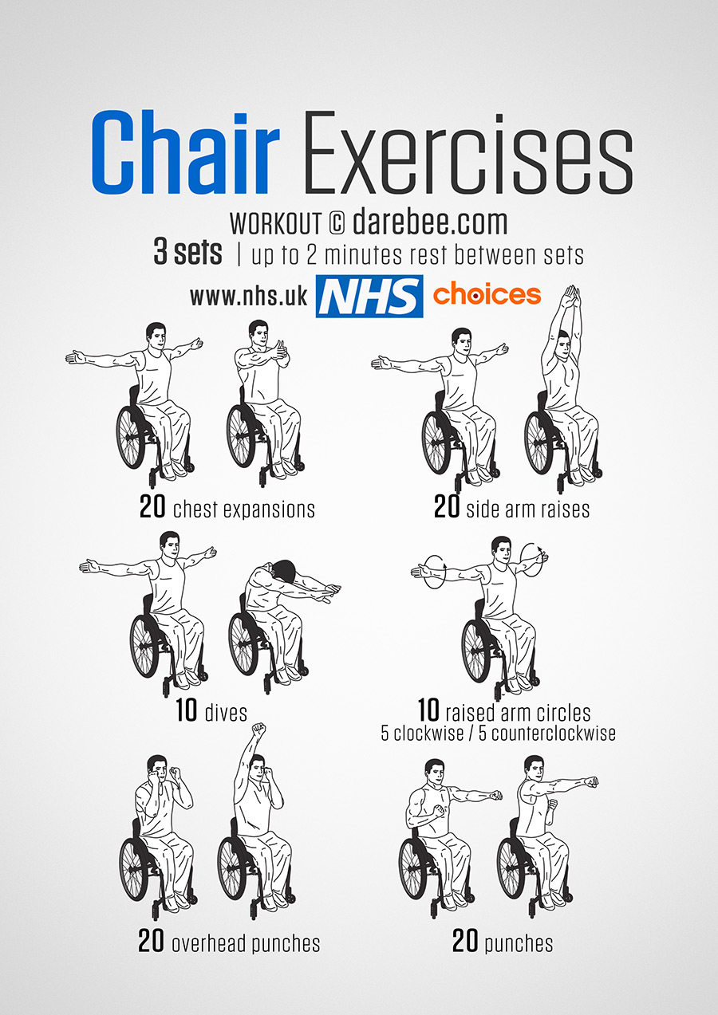

Appendix 3:

Appendix 3:
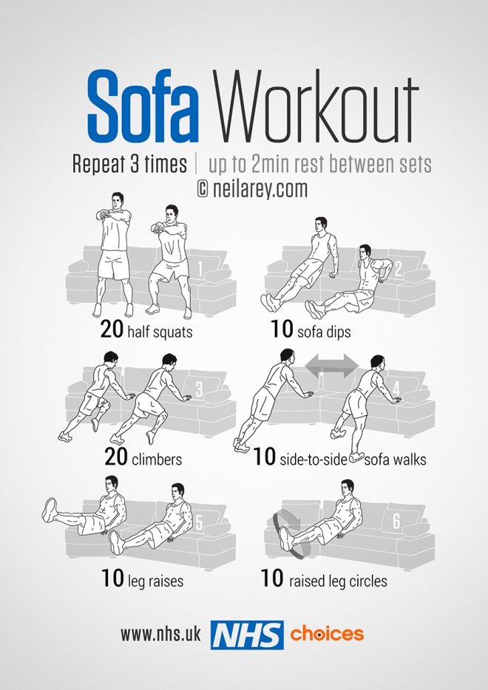
There are also a number of online gym and exercise programs that you can explore and follow if you go to www.youtube.com and search.

Appendix 4:

Useful contact numbers
Out of Hours GP: 028 71865195
The Samaritans: 028 82244944
Lifeline: 0808 808 8000
Fermanagh and Omagh Council: 0300 303 1777
Useful Mental Health Apps

Be Mindful
An online course to help reduce stress and anxiety using mindfulness-based cognitive therapy
£30.00

Beat Panic
Overcome panic attacks and anxiety wherever you happen to be
£0.99

Big White Wall
Get round-the-clock support from therapists to help you cope with stress and anxiety
Free

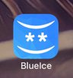

BlueIce
This app helps young people manage their emotions and reduce urges to self-harm
Free

Calm Harm
Reduce urges to self-harm and manage emotions in a more positive way
Free

Catch It
Learn to manage negative thoughts and look at problems differently
Free

Chill Panda
These digital tools meet NHS quality standards for safety, usability and accessibility and are being tested now with NHS patients to see if there is sufficient evidence to provide them an NHS stamp of approval.
Being tested in the NHS
Use breathing techniques to help you relax more, worry less and feel better
Free

Cove
These digital tools meet NHS quality standards for safety, usability and accessibility and are being tested now with NHS patients to see if there is sufficient evidence to provide them an NHS stamp of approval.
Being tested in the NHS
Create music to reflect emotions like joy, sadness and anger to help express how you feel
Free

distrACT
Quick and discreet access to information and advice about self-harm and suicidal thoughts
Free

eQuoo: Emotional Fitness Game
Use adventure games designed by psychologists to help you increase your emotional fitness
Free, with in-app purchases

Feeling Good: positive mindset
Use audio tracks to help relax your body and mind and build your confidence
Free, with in-app purchases

Ieso
Connect confidentially and securely with mental health therapists using instant messaging
Free in some areas

MeeTwo
A safe and secure forum for teenagers wanting to discuss any issue affecting their lives
Free

My Possible Self: The Mental Health App
Learn how to manage fear, anxiety and stress and tackle unhelpful thinking
Free, with in-app purchases

SilverCloud
An eight-week course to help you manage stress, anxiety and depression at your own pace
Free

Sleepio
An online sleep improvement programme, clinically proven to help you fall asleep faster
Free in some areas

Sleepstation
Connect with a team of sleep experts to help you fall asleep or stay asleep through the night
Free with GP referral

Stress & Anxiety Companion
Breathing exercises, relaxing music and games to help calm your mind and change negative thoughts
Free, with in-app purchases

Student Health App
Reduce your worries, feel more confident and get the health information you need as a student
Free

Thrive
Use games to track your mood and teach yourself methods to take control of stress and anxiety
Free

