Higher risk areas include:
- Hubei province (including Wuhan) China (visited in the past 14 days).
or (visited since 19 February 2020):
- Iran
- Daegu Metropolitan City and Cheongdo County in South Korea
- Any of these lockdown areas in Northern Italy:
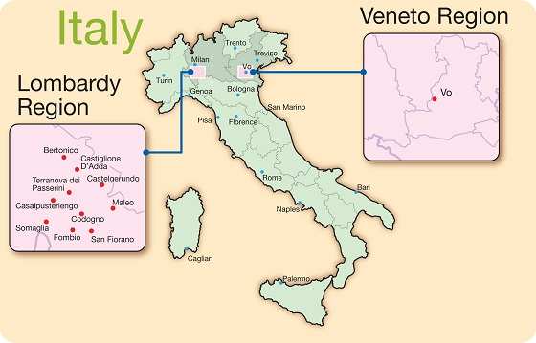
Towns in Lombardy:
- Bertonico,
- Castelgerundo,
- Castiglione d'Adda,
- Codogno,
- Fombio,
- Maleo,
- San Fiorano,
- Somaglia,
- Terranova dei Passerini.
Towns in Veneto:
- Vo’ Euganeo

_______________________________

Lower risk areas

_______________________________
Travellers who have visited lower risk areas do not need to undertake any special measures unless they have a cough, OR fever (temperature above 38˚C) OR shortness of breath
AND have been to any of the following places in the last 14 days:
- China (areas not mentioned in higher risk)
- Thailand
- Japan
- Republic of Korea (South Korea)
- Hong Kong
- Taiwan
- Singapore
- Malaysia
- Macau
or any of these places since 19 February 2020:
- All of Italy outside of the lockdown areas (including Sicily and Sardinia)
- Laos
- Myanmar
- Cambodia
- Vietnam
If you do experience any of the above symptoms please contact your GP by phone and stay indoors. If you DO NOT have any symptoms you do not need to take any action.

